Advanz Analytics, Inc. and Aspen Research Group Ltd. Present
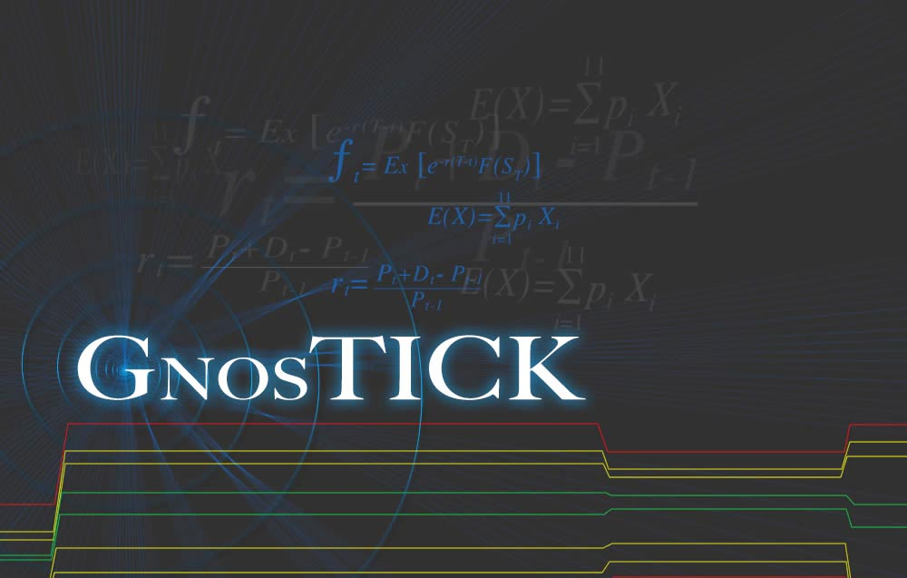
Aspen Research Group, Ltd. Technical Services
823 Grand Ave Suite 300 Glenwood Springs CO 81601. Tel. (970) 945-2921

Please read the following risk disclosure before you proceed.
The risk of loss in trading commodity futures contracts can be substantial. You should therefore carefully consider whether such trading is suitable for you in light of your financial condition. You may sustain a total loss of the initial margin funds and any additional funds that you deposit with your broker to establish or maintain a position in the commodity futures market.
Advanz GnosTick Studies
Aspen Research Group, Ltd.
823 Grand Avenue, Suite 300
Glenwood Springs, Colorado 81601
Sales: 800 359 1121
Support: 970 945 2921
Telefax: 970 945 9619
Email: sales@aspenres.com
Information in this document is subject to change without notice. No part of this document may be reproduced or transmitted in any form or by any means, electronic or mechanical, for any purpose, without the expressed written consent of Aspen Research Group, Ltd.
Aspen Research Group® and Aspen Graphics® are registered trademarks of Aspen Research Group in the United States and other countries.
© 2026, Aspen Research Group, Ltd. ALL RIGHTS RESERVED.
indows®, Windows® NT, Windows® 95 and Windows® 98, Windows 2000®, Windows XP® , and Windows Vista® are registered trademarks of Microsoft Corporation in the United States and other countries.
This document describes software designed to monitor stocks, commodities, and other market instruments. Using this software to sell or purchase these instruments may have significant financial implications. Please consult a professional before using Aspen Optionalysis or other Aspen Graphics features to sell or purchase these instruments.

Revision History
Author | Date | Nature of Edits
MEM | 1/28/2009 | Created.
Table 1: Revision History
This publication was last modified by Mitchell E. Mulhall on 2/17/2009 1:56 PM.

Table of Contents
Revision History i
Table of Contents ii
Figures vi
Tables viii
1 Introduction 1
Document Overview 1
Conventions 1
2 Advanz GnosTICK Studies 2
GnosTICK Levels 3
Parameters: 4
GnosTICK Accelerator 5
Parameters 6
GnosTICK R³ 7
Parameters 8
3 GnosTICK Studies—by Joe Garcia-Rios 9
The GnosTICK™—Introduction 9
GnosTICK™ Levels Overview 10
How the Indicator Works 10
Basic Features 10
Strategy Techniques 10
Strategy 1 11
Strategy 2 12
Strategy 3 13
Strategy 4 14
GnosTICK™ Risk Controller – The Risk Management 15
Market Risk – A Rule-based Approach 15
Trading Capital - Foundation of Survival 15
Position Sizing - Size Always Matters, Smaller is Smarter 15
Leverage - A Double Edged Sword 15
GnosTICK™ Money Manager – The Money Management 16
Allocating Capital - Scientific Art 16
Decision levels - The GnosTICK Visual Aid 16
Analyzing Risk Reward Ratio – Trader’s Math 17
Position Sizing – How Much Should You Bet on Each Trade? 18
The K factor 18
Total K = Total Volatility 18
K Applications 19
Maximum Position Size - The 2% Rule 20
GnosTICK™ Strategies – The Rules of Engagement 21
Order Types - Entries 21
Buy to Open – Buying Long 21
Sell to Open – Short Selling 21
Order Types - Exits 22
Sell to Close 22
Buy to Close 22
Stop Loss 22
Profit Target 22
Trailing Stop 22
Order Types – Multiple Usages 23
Market Order 23
Limit Order 23
OCO (One Cancels Other) 23
If-Then Order 23
If-Then OCO 23
Entries - Tilting the Odds 24
Time Based–It all Begins at T Time 24
Filter Based – Conditional Signals 25
Price Pattern Based – Chart Reading 25
Trend Direction – Underlying Conditions 25
Up Trend – Rallies 26
Down Trend – Sell Offs 27
No Trend – Waiting Period 28
Breakouts/Breakdowns 30
Statistically Based - Technical Indicators 31
Exits – Three Varieties 32
Stop Loss 33
Trailing Stop 34
Profit Target 35
Market Selection – Finding the Right Edge 36
The Quant Report – Numeric Scanning Power 36
Making it Happen – Learn, Train, Trade 36
4 GnosTICK Functions 37
GNOSACC() 38
GNOSRRRPROFIT() 39
GNOSRRRLOSS() 40
GNOSRRRRATIO() 41
GNOSLVL() 42
GNOSLVLAR1() 43
GNOSLVLBR1() 44
GNOSLVLMU() 45
GNOSLVLML() 46
GNOSLVLAS1() 47
GNOSLVLBS1() 48
GNOSLVLS2() 49
5 EMAIL ALERTS 50
Writing a Formula 50
What’s In A Name? 52
Declaring Variables 53
Using Aspen Functions 54
Logic And Flow 56
Creating an Alarm 58
Index 64
References 65

Figures
Figure 1: GnosTICK Levels overlay. 3
Figure 2: Gnos Levels parameters dialog. 4
Figure 3: GnosTICK Accelerator overlay. 5
Figure 4: Gnos Accelerator parameters dialog. 6
Figure 5: Gnos R3 study. 7
Figure 6: Gnos R3 parameters dialog. 8
Figure 7: GnosTICK Studies together. 9
Figure 8: Strategy 1. 11
Figure 9: Strategy 2. 12
Figure 10: Strategy 3. 13
Figure 11: Strategy 4. 14
Figure 12: GnosTICK decision levels. 16
Figure 13: GnosTICK Studies together. 20
Figure 14: GnosTICK entry model with T Time. The price chart below illustrates the open for the SPY (SPDRs), the ETF (Exchange Traded Fund) that mimics the S&P500 cash market. 24
Figure 15: GnosTICK up trends. 26
Figure 16: GnosTICK sell-offs. 27
Figure 17: GnosTICK in a non-trend market. 28
Figure 18: GnosTICK entry model with Trend Filter. The chart below utilizes two moving averages to signal a short term uptrend driven trade entry. 29
Figure 19: GnosTICK entry model with a Breakdown Filter and a Breakout Filter. 30
Figure 20: GnosTICK entry model with a Momentum Filter. The chart utilizes CCI Average (Commodity Channel Index) as a filter to signal a momentum-driven trade entry. 31
Figure 21: The chart above is of the GBP/USD demonstrating a GnosTICK stop loss model based on direction and money factors. 33
Figure 22: The chart above of the USD/JPY demonstrates the GnosTICK trailing stop model utilizing the R1a, which is 1st resistance represented by the yellow line, as the trigger to initiate the trailing stop order. 34
Figure 23: This chart of the Barclay’s Euro US Dollar cross demonstrates a GnosTICK profit target model utilizing the R2 line, which is 2nd resistance represented by the red line. 35
Figure 24: Formula Manager. 51
Figure 25: Formula Editor. 51
Figure 26: The Alarms… selection. 58
Figure 27: The Alarm List. 58
Figure 28: The New Alarm dialog. 59
Figure 29: Using the analyse() formula as a Trigger condition. 60
Figure 30: Entering descriptive information about the alarm in the Memorandum field. 61
Figure 31: Using the analyse() formula as a Trigger condition. 62
Figure 32: Setting alerts on several instruments. 63
Figure 33: An email alert. 63
Figure 34: The Aspen Graphics alarm window. 63

Tables
Table 1: Revision History i
Table 2: Conventions 1
Table 3: Gnos Levels parameters. 4
Table 4: GnosTICK Accelterator legend. 5
Table 5: Gnos Accelerator parameters. 6
Table 6: Gnos R3 parameters. 8
Table 7: GNOSACC() function arguments. 38
Table 8: GNOSRRRPROFIT() function arguments. 39
Table 9: GNOSRRRLOSS() function arguments. 40
Table 10: GNOSRRRRATIO() function arguments. 41
Table 11: GNOSLVL() function arguments. 42
Table 12: GNOSLVLAR1() function arguments. 43
Table 13: GNOSLVLBR1() function arguments. 44
Table 14: GNOSLVLMU() function arguments. 45
Table 15: GNOSLVLML() function arguments. 46
Table 16: GNOSLVLAS1() function arguments. 47
Table 17: GNOSLVLBS1() function arguments. 48
Table 18: GNOSLVLS2() function arguments. 49
Table 19: Tools Menu, Formulas… selection. 50
Table 20: GnosTICK values and their functions. 54
Table 21: A closer look at GnosTICK Accelerator arguments and their functions. 56
Table 22: The range of possible return values from the analyse() formula. 57

1 Introduction
This document describes the design and implementation of GnosTICK Studies in Aspen Graphics. This document is written for the end user communities of Aspen Research Group, Ltd, and Advanz Analytics, Inc.
Be advised that the material in this document is subject to revision or correction by Aspen Research Group, Ltd. at any time. If you have any questions or suggestions regarding the accuracy or usability of this document, please email them to mmulhall@aspenres.com with the subject line “GnosTICK Studies Documentation.”
This document employs several conventions to draw attention to important items or commentary. These conventions are:
Convention | Meaning
 | This symbol emphasizes information that is important to a proper understanding of the topic at hand.
 | This symbol identifies comments regarding warnings, exceptions, or limitations regarding the subject under discussion.
 | This “recycle” symbol indicates that the programmer is responsible to “clean up” memory. Usually this means that a data item was dynamically allocated by Aspen but must be freed by the programmer when it is no longer needed. A special API function is used to free this kind of memory.
New Courier font | Aspen Graphics formula language examples and other coding conventions are shown in the Courier New font.
… (elipses) | In code examples, elipses indicate that a section of code has been snipped. Refer to either the source files or Appendix B for additional context.
hyperlink | Hyperlinks appear (in Microsoft Word®) in blue.
Table 2: Conventions

2 Advanz GnosTICK Studies
This section describes and explains how to use the GnosTICK Levels, GnosTICK Accelerator and GnosTICK R3 studies. These studies are available by subscription on Aspen Graphics 4.20 software. For more information about subscribing, call Aspen Research sales:
New York | 800 359 1121
Chicago | 800 359 1121
London | 44 20 7531 1190
Singapore | 65 6232 2779
All three studies are based on GnosTICK Levels derived from daily data.
Advanz GnosTICK studies are designed for use in intraday time bases. A five-minute chart is optimal for GnosTICK analysis.
Advanz GnosTICK studies are designed for analysis of foreign exchange instruments and currencies, including futures and equities.

GnosTICK Levels
The GnosTICK Levels study is similar to the Pivot Points study. GnosTICK Levels displays eight lines. The outermost lines (red) are the Support 2 (below) and Resistance 2 levels (above). The intermediate yellow lines are Support 1 and Resistance 1 lines. The center-most pair defines a channel of neutrality bordered by the Mid Up and Mid Low lines (green). Prices above this channel are bullish, and prices below the channel are bearish.
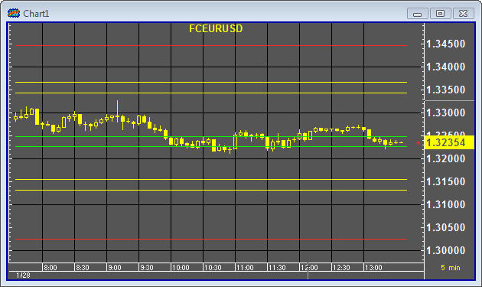
Figure 1: GnosTICK Levels overlay.
The lines in the GnosTICK Levels study have several functions:
- Buy/Sell triggers
- Market neutrality triggers
- Re-entry levels
- Profit targets
- Stop Loss levels
- Trailing stop levels
The center channel lines (green) serve to delineate bullish and bearish territory. Action above the upper line is bullish while action below the lower line is bearish.
Once you’ve entered a position, GnosTICK lines serve as stop loss and trailing stop levels. Similarly, when you’re managing a position, GnosTICK lines serve as profit targets and re-entry levels.

Parameters:
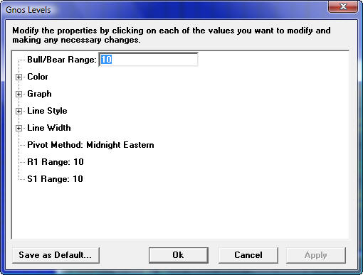
Figure 2: Gnos Levels parameters dialog.
Parameter | Function
Bull/Bear Range | A number representing a percentage. This parameter controls the range, or height, of the channel defined by the MidUp and MidLow lines. The default is 10, or ten percent.
Gnos Demarcation | Sets the starting point for all Pivot calculations.  The pivot method is an important consideration when trading foreign exchange instruments at the start of trading Sunday evening. Typically the Sunday evening session does not undergo huge swings, at least compared to a weekday session. You can minimize the effect of a narrow Sunday trading range by modifying the Gnos Demarcation.
  Option | Function
  Midnight at Exchange | Uses midnight at the instrument’s exchange as the starting point.
  Midnight Eastern | Uses midnight in the Eastern time zone of the United States (EST or EDT) as the starting point.
  Midnight GMT | Uses midnight in Greenwich Mean Time as the starting point.
  Trading Day | Uses the instrument’s opening time as the starting point.
R1 Range | A number representing a percentage. This parameter controls the range, or height, defined by the Resistance 1 channel. The default is 10, or ten percent.
S1 Range | A number representing a percentage. This parameter controls the range, or height, defined by the Support 1 channel. The default is 10, or ten percent.
Table 3: Gnos Levels parameters.

GnosTICK Accelerator
The GnosTICK Accelerator uses on-chart text and is similar to DeMark’s Sequential overlay in appearance. The values indicate long or short opportunities and are weighted based on several criteria. The following table enumerates possible values and meanings:
Location | Value | Meaning
Below the bar | 5 | Strong long
 | 3 | Medium long
 | 1 | Price acceleration exhausted or possible trend reversal
Above the bar | 5 | Strong short
 | 3 | Medium short
 | 1 | Price acceleration exhausted or possible trend reversal
Table 4: GnosTICK Accelterator legend.
Buy opportunities are displayed below the bar. Sell opportunities are displayed above the bar.
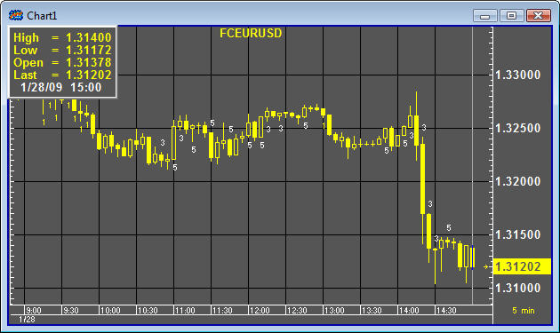
Figure 3: GnosTICK Accelerator overlay.

Parameters
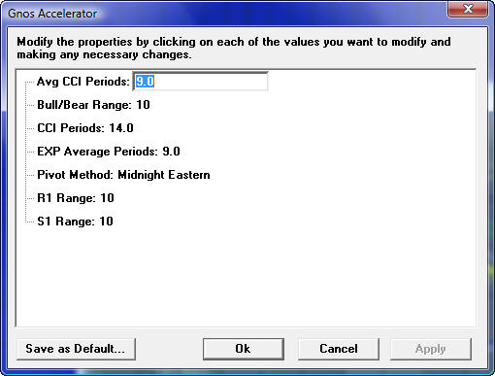
Figure 4: Gnos Accelerator parameters dialog.
Parameter | Function
Bull/Bear Range | A number representing a percentage. This parameter controls the range, or height, of the channel defined by the MidUp and MidLow lines. The default is 10, or ten percent.
Gnos Demarcation | Sets the starting point for all Pivot calculations.
  Option | Function
  Midnight at Exchange | Uses midnight at the instrument’s exchange as the starting point.
  Midnight Eastern | Uses midnight in the Eastern time zone of the United States (EST or EDT) as the starting point.
  Midnight GMT | Uses midnight in Greenwich Mean Time as the starting point.
  Trading Day | Uses the instrument’s opening time as the starting point.
R1 Range | A number representing a percentage. This parameter controls the range, or height, defined by the Resistance 1 channel. The default is 10, or ten percent.
S1 Range | A number representing a percentage. This parameter controls the range, or height, defined by the Support 1 channel. The default is 10, or ten percent.
Table 5: Gnos Accelerator parameters.

GnosTICK R³
R³ is a study in oscillator form. It consists of four values:
R³ Line | Meaning
Reward (“Prof”) | Reward is the difference between the GnosTICK Level identified as a profit target and the current price.
Risk (“Loss”) | Risk is the difference between the current price and GnosTICK Level identified as a stop-loss or trailing stop.
Ratio | The ratio is the quotient of Reward divided by Risk.
Limit | The Limit value is a reflection of the Ratio Limit study parameter. This value serves as a strength level. Ratio values greater than this value give a signal greater credence. When the Ratio value is greater on a buy signal or lesser on a sell, a cyan dot is plotted on the histogram.
All three lines are not available foreign exchange instruments. Trading units on foreign exchange instruments fail to produce a meaningful ratio value because the Risk and Reward values are so small. The calculated values can be seen in the cursor window. This is expected behavior and mimics Advanz studies on TradeStation.
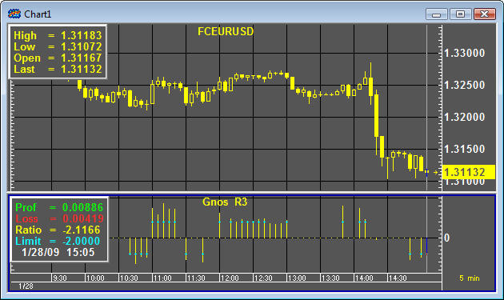
Figure 5: Gnos R3 study.
R³ relies heavily on the GnosTICK Levels study. The first order of business is to determine where the current price is in relation to the MidUp and MidLow channel. From there, the study applies rules that define profit targets and stop-loss levels among the GnosTICK Levels.

Parameters
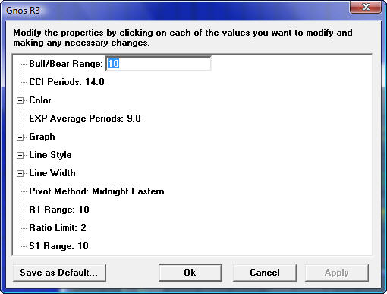
Figure 6: Gnos R3 parameters dialog.
Parameter | Function
Bull/Bear Range | A number representing a percentage. This parameter controls the range, or height, of the channel defined by the MidUp and MidLow lines. The default is 10, or ten percent.
Gnos Demarcation | Sets the starting point for all Pivot calculations.
  Option | Function
  Midnight at Exchange | Uses midnight at the instrument’s exchange as the starting point.
  Midnight Eastern | Uses midnight in the Eastern time zone of the United States (EST or EDT) as the starting point.
  Midnight GMT | Uses midnight in Greenwich Mean Time as the starting point.
  Trading Day | Uses the instrument’s opening time as the starting point.
R1 Range | A number representing a percentage. This parameter controls the range, or height, defined by the Resistance 1 channel. The default is 10, or ten percent.
S1 Range | A number representing a percentage. This parameter controls the range, or height, defined by the Support 1 channel. The default is 10, or ten percent.
Table 6: Gnos R3 parameters.

3 GnosTICK Studies—by Joe Garcia-Rios
In this user guide you will discover the knowledge and logic to trade the GnosTICK Levels Indicator. As a comprehensive guide, you will gain access to innovative methods to take profits from the markets while controlling risk. The concept, methods and tools are outlined in an easy to understand step by step format. One of the toughest challenges for traders is forecasting market behavior. However, market behavior is truly unpredictable. The GnosTICK's scientific methodology to trading the markets is based on odds and the objective is to keep the odds in your favor. Like any other odds approach you have to know and follow the rules. The purpose of rules is to make trading decisions as objective and consistent as possible. So everyone may benefit from this user guide, the exact logic is outlined with all the necessary rules needed for understanding the knowledge and procedure that drives the GnosTICK Levels Indicator.
~Joe Garcia-Rios, President and Director of Systems Development, Advanz Analytics, Inc.
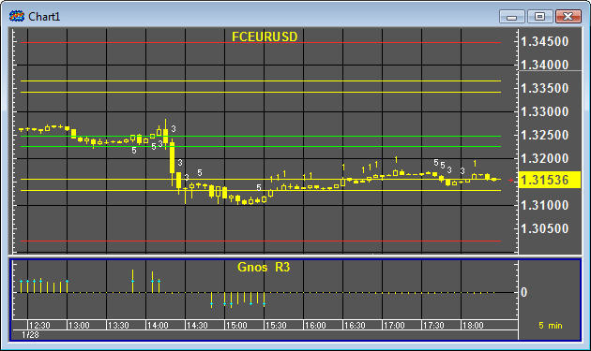
Figure 7: GnosTICK Studies together.

The GnosTICK™—Introduction
GnosTICK gnos·tick \ˈnäs-tik\ derived from two words, gnosis and tick. Gnosis stems from the Greek word for Knowledge (γνώσις). Tick is the word used to describe movements in different size price increments for the financial markets. In the trading realm, GnosTICK is the understanding of market mysteries: Knowledge of market truths reputedly possessed by the GnosTICK traders who believe them to be essential to salvation in the financial markets.

GnosTICK™ Levels Overview
The GnosTICK Levels is a volatility based algorithm indicator designed to forecast the next trading day's bullish/bearish bias with key support and resistance levels. It was developed by a professional trader to help assist his active trading team make important and quick trading decisions.
It is dynamic, providing the active trader with key levels to enter and exit the markets as prices change and move through out various trading sessions.
The GnosTICK Levels Indicator was designed to accommodate both the novice and the veteran trader. Its applications begin with simple and easy to apply techniques as well as complex and sophisticated algorithms. It’s the indicator to keep throughout your trading experience and development.

How the Indicator Works
The GnosTICK Levels has five key levels represented in green, yellow and red lines as can be seen in the graph below. An important feature is the center level which is illustrated by two green lines. The higher or upper green line (1.5526) indicates bullish territory and conversely the lower green line (1.5513) indicates bearish territory. These green lines can also work as bullish and bearish triggers for entering positions.
The next feature of the GnosTick Levels is to forecast key support and resistance levels. You will notice two yellow lines above and two yellow lines below the center green lines. These lines represent important support and resistance target levels that will help to identify exit points to secure profitable trades. They can also be used to re enter positions and/or to add more position size. We will discuss various applications later in this user guide. The first resistance yellow line is referred to as Resistance 1a (1.5569) and the second resistance yellow line is referred to as Resistance 1b (1.5580). The bottom set of yellow lines are Support 1a (1.5460) and Support 1b (1.5499). The outmost set of levels is illustrated in red and they represent Resistance 2 (1.5640) and Support 2 (1.5401).

Basic Features
- Bull/Bear trigger Levels
- Neutral Levels
- Reentry Levels
- Profit Levels
- Stop Loss Levels
- Trailing Stop Levels

Strategy Techniques
There are various strategy techniques you can use with the GnosTICK Levels indicator. The following examples will give you an idea of the diverse and dynamic nature of the GnosTICK Levels.
For illustrative purposes we have outlined four (4) basic yet powerful strategy techniques that our trading team frequently applies. The model’s ‘forward looking” approach provides numerous variations that the active trader can apply, depending on their level of expertise.

Strategy 1
The first strategy technique utilizes the bull/bear trigger to open a long (buy) or short (sell) position. The chart below illustrates a buy signal to open long GBPUSD at the European morning session (2:00 am EST). The target exit to close the position is Resistance 2 displayed at the red level line. Conversely for shorting opportunities you would open a short position below the bear trigger and the take profit target would be Support 2, also displayed in a red line.
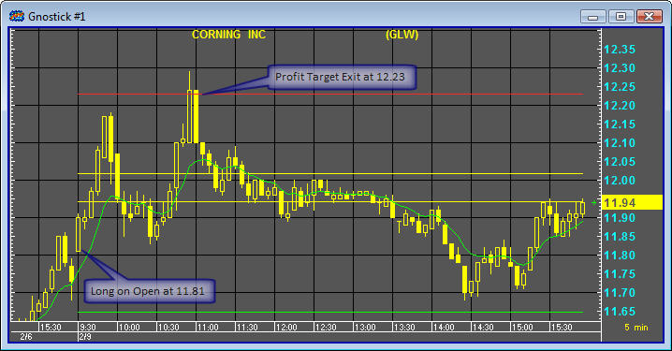
Figure 8: Strategy 1.

Strategy 2
Another favorite strategy deals with multiple profit target exits. The first profit target is Resistance 1a illustrated in the first yellow line. You would close/liquidate a portion of your initial position size once prices reach this first level, Resistance 1a. The position size would be determined by risk management techniques later discussed. The remaining open portion of the initial position should be closed at the second resistance illustrated in a red line, Resistance 2. Conversely, you would apply the same rules to shorting opportunities. This money management method of exiting positions is referred to as “scaling down.”
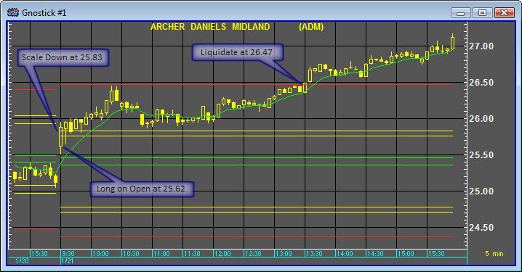
Figure 9: Strategy 2.

Strategy 3
Strategy 3 also utilizes multiple profit target exits but includes various entry points as well. When using this technique you would close your entire short position when the market price reaches the first support, Support 1a illustrated in the yellow line. You would then re-open the short position when the Support 1b, lowest yellow line, is breached. Your final profit target exit is Support 2 represented by the lower red line. You would apply the same method to long opportunities in the market.
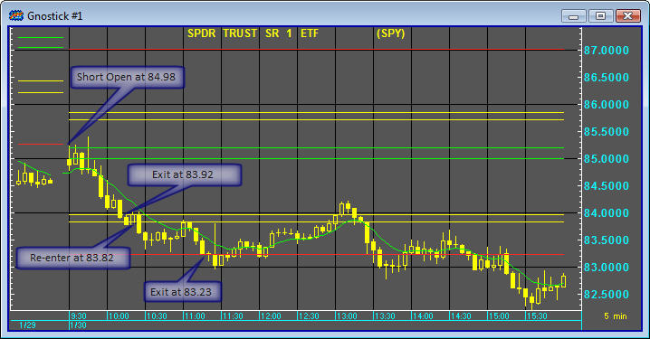
Figure 10: Strategy 3.

Strategy 4
This commonly used strategy involves multiple entry levels accompanied by a profit target exit. Traders applying this strategy would open their first position when the first buy signal is triggered and then add to the position when the market price breaches the Resistance 1b level, illustrated in the highest yellow line. Both positions would then be liquidated when the Resistance 2 level, highest red line, is reached. The money management method of this trade is referred to as “pyramiding profits.”
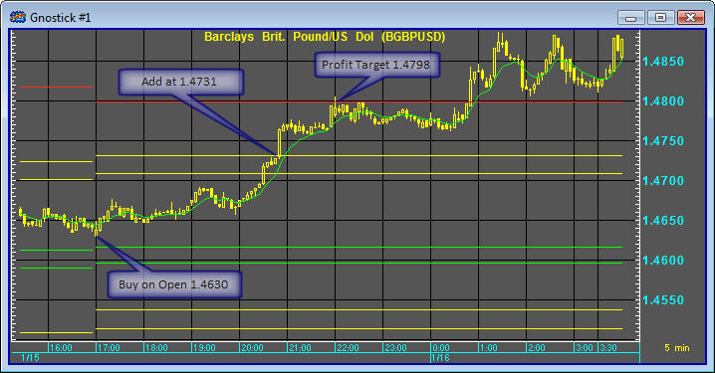
Figure 11: Strategy 4.

GnosTICK™ Risk Controller – The Risk Management

Market Risk – A Rule-based Approach
Managing risk is at the forefront of the GnosTICK approach to trading the markets. Financial risks are classified into a wide range of categories such as market risks, liquidity risks, operational risks, technology risks and credit risks to name a few. At times these risks have the potential to interact with each other; however our main focus for this user guide will be based on market risk. Market risk occurs from price movements in the markets. Market risk can be categorized into directional and non directional risks.
Directional risk refers to exposure to the direction of movements in financial variables such as commodity prices, foreign exchange rates, interest rates, stock prices etc. Non directional risks can include negative carry charges on foreign currency exchange holdings, margin interest on equity positions etc. A very important aspect of the GnosTICK logic is that it encourages its users to quantify market risk in a systematic way.

Trading Capital - Foundation of Survival
The first rule of risk management is to trade ONLY with capital you can afford to lose. The emotional consequence of trading are amplified exponentially when you are dependent on the results. The need to make profitable trades forces traders to be attached to the outcome. This type of attachment typically influences the decision making process of trading in a negative way. More often than not, fear and/or greed will result in poor judgment, resulting in losses. You are the only one that can determine how much money you can afford to lose. Therefore, consider losses from the very start, it will help you in evaluating the amount of money you can risk while curbing your expectations.

Position Sizing - Size Always Matters, Smaller is Smarter
The second rule of risk management is to ONLY take positions that fit your risk tolerance level. The most common mistake made by novice traders is disregard for risk management by taking overly large positions. Successful trading is developed over time by constantly following a pre-set of rules and preserving trading capital. The bigger the position, the more intense the feeling of greed and-or fear, often causing novice traders to abandon their discipline and trade emotionally. It takes strict discipline and careful preparation to match your position size to your risk tolerance.

Leverage - A Double Edged Sword
The third rule of risk management is to ONLY use leverage when you fully understand how it works and how it can bankrupt you. Using leverage is an accepted and common practice among GnosTICK traders. It is of utmost importance for traders to be aware of the risks of leverage. You should learn how to handle the power it offers before you include it in your trading plan. Leverage magnifies both gains and losses. It is recommended for novice traders to begin their trading experience with very little leverage. As the trader's knowledge expands and his trading capital increases with profits, then the trader can increase his leverage accordingly.

GnosTICK™ Money Manager – The Money Management

Allocating Capital - Scientific Art
Money management is the art and science of allocating capital and timing entries and exits to and from the market. Your ability to succeed as a trader will depend greatly on your money management skills. One of the benefits of the GnosTICK Levels approach is the ease to visualize price levels that will require your attention to take action, whether it’s to initiate a new position or to manage existing positions. Most traders are able to make quicker decisions when they can see it drawn on the price chart in simple lines in front of them.

Decision levels - The GnosTICK Visual Aid
One phase of money management is to predetermine buy and sell levels. This approach will enable you to analyze a trade before you are emotionally tied to it. The GnosTICK Levels is designed to give you a visual picture of key levels in the markets. Once prices reach or breach certain levels, your money management plan will kick in to initiate positions, lock in profits or limit your losses. This visual aid method will help you to make quick decisions during the trading sessions, regardless of market noise. The use of GnosTICK’s decision levels is much more useful than trying to select specific entry and exit points based on price alone. Decision levels can be useful in the following money management techniques:
- They force you to visualize potential price movements within trading ranges.
- To the trained eye, they can assist you to quickly visualize favorable risk to reward ratios.
- They can keep you on the right side of the trend.
- Stop losses can be pin pointed to minimize potential losses.
- Trailing stops and profit targets are also easily identified.

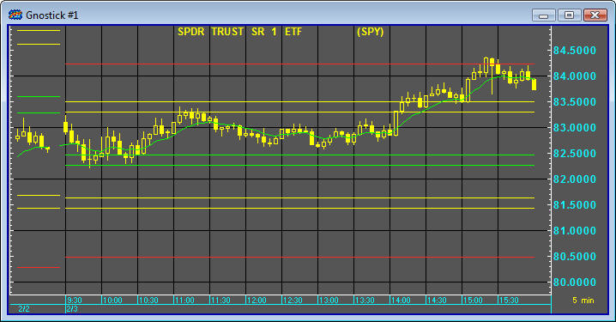
Figure 12: GnosTICK decision levels.

Analyzing Risk Reward Ratio – Trader’s Math
Once you have identified a trading opportunity, you will need to examine the potential for profit and loss. Consider it a necessary exercise before you place a trade, especially if you are new to the game. As you gain trading experience you will find it will come to you as second nature. Experienced GnosTICK traders can visualize the potential risk reward ratio by just looking at the GnosTICK levels on a price chart. With time and practice, you should be able to gain the necessary knowledge and experience to do the same.
The general rule for selecting an appropriate risk to reward ratio is 2.5:1 or better. You will find ten simple steps outlined to evaluate a trade. Steps 1 through 5 are extremely important and require a quick method to analyze while steps 5 through 10 are scenarios that you will gather from being well informed as an active trading participant.
The ten step process for trade selection is as follows:
- What is the potential loss on the trade including commission and slippage?
- What is the potential profit on the trade including commission and slippage?
- Compare the total potential profit versus the potential loss.
- What is the price trend? Up, down, sideways or is it changing?
- Is the market overbought, oversold or in the middle of a move?
- What is the volatility of the market?
- How does the current trend fit within the context of the business cycle? What is the condition of the economy? Where is inflation, interest rates and the Fed's or central banks policy towards it?
- Any economic indicators, news or central bank meetings to be announced in the short term that could have an impact on the trade you are considering?
- Have you considered liquidity and favorable “time” to initiate the trade?
- On what side of the trade is the consensus? On what side is the potential risk due to a sudden change caused by surprised news or events?
The following is an example of a favorable risk reward ratio:
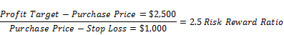
Potential percentage Gain:
Beginning Balance $10,000
Profitable trade $ 2,500
Ending Balance $12,000 = 25% Percentage Gain
Potential percentage Loss:
Beginning Balance $10,000
Losing trade $ 1,000
Ending Balance $ 9,000 = 10% Percentage Loss

Position Sizing – How Much Should You Bet on Each Trade?
The GnosTICK Levels Indicator serves as an important tool in the process of determining risk reward ratio and trade position size, also referred to as bet sizing. The process begins with the measurement of daily market volatility. The GnosTICK’s approach is to measure volatility in terms of levels or daily ranges. This is one of the most important sections of this user guide. This section has the potential to teach you how to tilt the odds in your favor. From the concept to the formulas to actual trading, the process is of utmost importance to your success as a GnosTICK trader. Review this section over and over until its part of your thinking process.

The K factor
The GnosTICK system utilizes code names and/or letters as a communication tool. The code letter for volatility is “K”. The K factor is at the root of every trade decision you will ever have to make. It’s vital in determining a few key factors in your money management techniques such as favorable risk reward ratio, proper position size, acceptable stop loss level, tolerable scaling down methods and pyramiding profits to name a few.

Total K = Total Volatility
The K’s lexis and the procedure to calculate are as follows:
Market K is the Total Volatility for the current trading session as measured by the GnosTICK Levels Indicator.
Market K is calculated by subtracting the Resistance Level 2 price from the Support Level 2 price. Both levels are identified by the Red outer lines.
Bullish K is the Long side volatility (buy to open)
Bullish K is calculated by subtracting the Resistance Level 2 price from the Bullish Trigger line price. Resistance level 2 line is in Red while the Bullish Trigger line is Green.
Bearish K is the Short side volatility (sell to open)
Bearish K is calculated by subtracting the Bearish Trigger line price from the Support level 2 price. Bearish Trigger line is in Green while the Support level 2 line is in Red.
Trade’s K is the Trade’s volatility, buy to open long position or sell short to open short position. Trade's K is calculated by subtracting the Profit Target price from Entry Price plus Stop Loss.

K Applications
Keep in mind that there are other K references, such as Bull/Bear Trigger to R1a or R1b, Weekly K, Monthly K, etc. These other K factors and their applications will be discussed in more detail in subsequent sections of the hand book. Once you are able to measure the K of the various GnosTICK levels and potential trades, you will then need to view them in terms of fractional increments. The increments should be in quarters, halves and/or thirds. The following illustration should provide you with examples of its multiple uses.
FX – GBP/USD British Pound vs. US Dollar / PIP Value / 1 = $10
Market K is 355 PIPS / $3,550 per Lot
R2 2.0104 – S2 1.9749 = 355
Bullish K is 165 PIPS / $1,650 per Lot
R2 2.0104 – BULL 1.9939= 165
Trade’s K is 183 PIPS / $1,830
(PT 2.0104 – EP) + SL = Trade’s K
Let’s take a closer look at the above example using strategy 1 as illustrated on the chart below. We begin trading the British Pound at midnight Eastern. The GBP/USD is trading at 1.4600 at the open, which happens to be above the Bullish Trigger Line of 1.4576 creating a buy long opportunity.
The trade’s K inputs are as follows:
Entry Price EP: triggered at open=1.4602
Profit Target PT: Resistance 2 =1.4891
Stop Loss SL: Bearish Trigger Line=1.4543
The Trade’s K analysis:

Now that we have the trade’s K, we will look at the next step which is the risk.
Reward analysis:
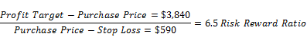
Potential percentage Gain:
Beginning Balance $10,000
Profitable trade $ 3,840
Ending Balance $13,840 = 38.4% Percentage Gain
Potential percentage Loss:
Beginning Balance $10,000
Losing trade $ 590
Ending Balance $ 9,420 = 5.9% Percentage Loss

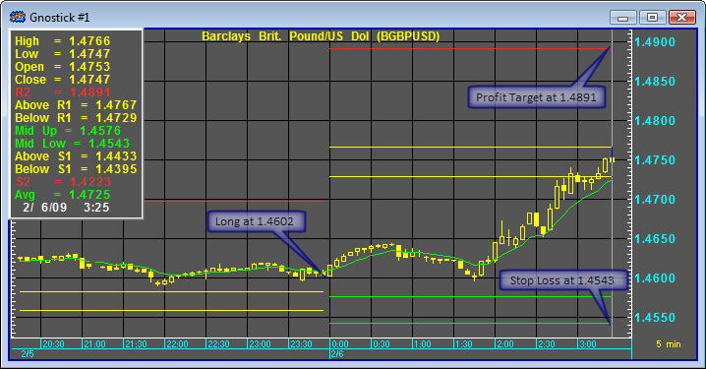
Figure 13: GnosTICK Studies together.

Maximum Position Size - The 2% Rule
The 2% rule is a simple and trust worthy approach to determining the maximum position size. This approach is geared to keep your exposure tight to only 2% of your total trading capital. This figure should be a sufficient amount to include the spread, commission and slippage. This means that the largest loss you should experience on any single trade is 2 percent of your trading capital. Keeping your losses to 2 percent per trade will mean that you might have to trade smaller positions. Successful traders aim to keep losses controlled and managed. By controlling losses you will be able to better focus on the next trade and better manage the winning trades. When you follow your pre set of rules, especially the 2% rule, your probability of success increases with the number of times you trade.

GnosTICK™ Strategies – The Rules of Engagement
At the core of the GnosTICK levels approach is a set of predetermined rules that dictates every action you will need to take. In this section you will discover multiple methods to enter and exit the markets, including the logic behind the strategies. You will also learn the different order types most frequently used in trading.

Order Types - Entries

Buy to Open – Buying Long
Indicates the opening of a long position in the market through the purchase of the desired contracts.

Sell to Open – Short Selling
Commonly used phrase to indicate the opening of a short position in the market through the sale of the contracts.

Order Types - Exits

Sell to Close
Represents the closing of an open long position through the sale of the contract.

Buy to Close
Indicates the closing of a short position in the market through the buy back of the contracts that had been sold short.

Stop Loss
A standing order to liquidate the position when the price goes to a predetermined level in order to limit the investor’s losses.

Profit Target
An order to close the open position that is executed when a price target set by the trader is hit in order to realize his profits.

Trailing Stop
A standing stop loss order used to protect profits without limiting the maximum possible gain by being set at a fixed distance or percentage above or below the market price.

Order Types – Multiple Usages

Market Order
An order to buy or sell a contract to be executed at the first available price after the order is placed. Even though you are almost guaranteed that your order will be fulfilled, you might not receive the price you saw before the order was sent.

Limit Order
An order type in which the buying or selling of the contract is done at a specific price set by the trader who creates a standing order for the broker to execute. A buy limit order can only be filled at the specified price or lower and a sell limit at the specified price or higher.

OCO (One Cancels Other)
An order containing a combination of two standing orders in which the execution of one automatically cancels the other.

If-Then Order
A two-legged order where one of the orders will only be placed upon the completion of the first one.

If-Then OCO
A two-legged order where an OCO is placed only if the first leg of the trade is executed.

Entries - Tilting the Odds
A good entry is one that tilts the odds in your favor at the very start for a profitable outcome. Good entries can also allow you tight stop loss orders for reduced risk. There are various entry techniques possible to employ with the GnosTICK Levels ranging from simple to complex. It would be prudent for you to start with simple approaches and as your knowledge and confidence increases; you can explore more sophisticated methods. Below you will find some basic GnosTICK entry models that will help you get started.

Time Based–It all Begins at T Time
It is of utmost importance for you to familiarize yourself with the most opportunistic times to trade the markets. Just as markets have different behavior, they each have distinctive times for favorable trade results. One of the key elements you will need to pay attention to is volume. Make sure you ONLY trade markets that have plenty of liquidity. Your chances of success increase by trading during the most liquid and/or during the highest volume segments of the trading session. For example, as shown in Illustration 1a below, the S&P 500 cash market’s ideal segments with the highest volume is from 9:30 am EST to 11:00 am EST and in the afternoon from 2:30 pm EST to the market’s close at 4:00 pm EST. Initiating positions based on this approach is referred to time based entries. In GnosTICK terms, we call it T time. Buy and sell signals to initiate positions begin with the appropriate T times. Since the T time for the S&P 500 cash is 9:30, you would initiate a long entry at the open if prices are in the Bullish trigger level, and conversely you would sell short when prices are below the bearish trigger level. Should prices oscillate between both trigger levels, you would not initiate any positions; this area is regarded as neutral. You would wait for prices to pierce on either bull/bear trigger line.
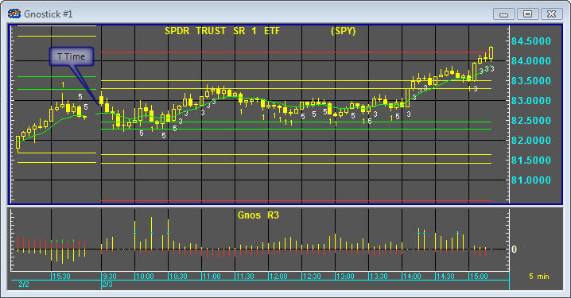
Figure 14: GnosTICK entry model with T Time. The price chart below illustrates the open for the SPY (SPDRs), the ETF (Exchange Traded Fund) that mimics the S&P500 cash market.

Filter Based – Conditional Signals
Adding filters to your trade decision process can tilt the odds further to your favor. As the name implies, filters act as a mechanism to reduce frequencies based on a pre determined set of conditions. Filters can be incorporated into the rules for entering and exiting trades and/or used for determining money management categories such as position sizing. Some of the most popular filters used for trade entry signals are:

Price Pattern Based – Chart Reading
Price patterns are valuable in providing the trader the ability to track more potential trading opportunities. They do not predict the future but if applied properly, they can increase your chance of success. They are useful in matching preferable strategies with the market’s current behavior.

Trend Direction – Underlying Conditions
One of the most powerful methods in trading is identifying and trading along the same side as the direction of the underlying trend. Trends come in many shapes and sizes. There are three separate and distinct types of trends: major trend (long term trend), minor trend (intermediate term trend) and micro trend (short term momentum based trend). At times you will see them interrelated one within the other. For example, a minor downtrend within a major uptrend and/or a micro downtrend within a minor uptrend. The combinations can go on and on. Your ability to identify the direction and type of trend; and be able to apply the most appropriate strategy can increase your odds of success significantly.

Up Trend – Rallies
An uptrend is a series of successive price movements that penetrate previous high price points in an upward slope, occasionally interrupted by price declines which terminate above the low price points of the preceding sell off, maintaining the upward slope. Rallies occur when the bulls (buyers) overpower the bears (sellers) by tilting the balance of supply and demand in their favor (buying pressure). You can identify an uptrend on a price chart when price movements consisting of higher highs and higher lows.
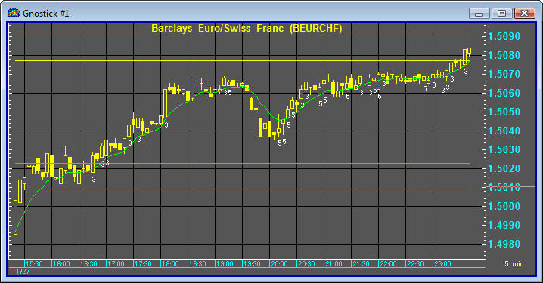
Figure 15: GnosTICK up trends.

Down Trend – Sell Offs
A downtrend is a series of successive price movements that penetrate previous low price points in a downward slope, occasionally interrupted by price increases which terminate below the high price points of the preceding rally maintaining the downward slope. Sell offs occur when the bears (sellers) overpower the bulls (buyers) by tilting the balance of supply and demand in their favor (selling pressure). One method of identifying a downtrend is by looking at a price chart where price movements consist of lower lows.
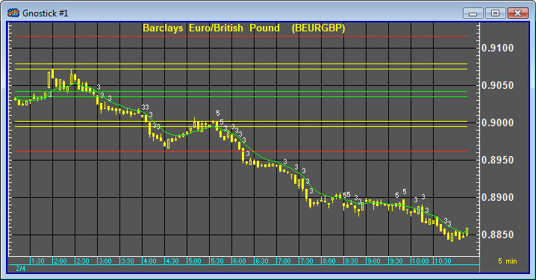
Figure 16: GnosTICK sell-offs.

No Trend – Waiting Period
One of the most difficult environments to trade the GnosTICK methodology is when there is no trend accompanied with low volatility. Non trending markets are also referred to as sideways markets, ranging markets and consolidating markets. A non trending market can be identified when prices oscillate around a steady center point. Typically after a rally or after a sell-off, traders realign their positions, digest the news if the move was event driven and wait for the next catalyst to trigger trade entries. This waiting period usually results in non trending sideways price action, a reflection of the bulls and the bears being equally balanced between supply and demand. Take special note that trading the GnosTICK method during non trending markets is not recommended, the odds of profitable trades are against you.
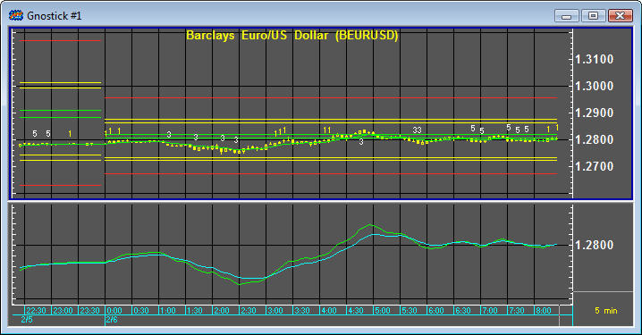
Figure 17: GnosTICK in a non-trend market.
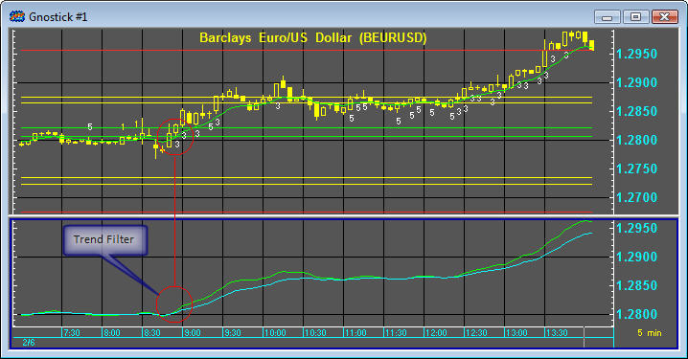
Figure 18: GnosTICK entry model with Trend Filter. The chart below utilizes two moving averages to signal a short term uptrend driven trade entry.

Breakouts/Breakdowns
After a market forms a pattern, it eventually begins a new trend direction. A breakout occurs when prices move through resistance. A breakdown occurs when prices move through support. Entries based on breakouts and breakdowns can be very simple and if applied properly, can be very powerful. Entering trades based on breakouts and breakdowns will assure you of getting on-board of a potentially large market move or trend.
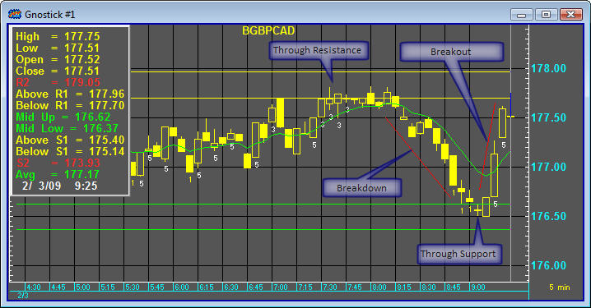
Figure 19: GnosTICK entry model with a Breakdown Filter and a Breakout Filter.

Statistically Based - Technical Indicators
A technical indicator is a series of data points that are derived by applying a formula to the price data of the market in question. It offers a unique perspective from which to analyze the price action. Some indicators are derived from simple formulas while others are complex formulas requiring additional knowledge and experience. Some of the most common technical indicators are RSI Relative Strength Indicator, CCI Commodity Channel Index, SMA Simple Moving Average and Oscillator just to name a few.
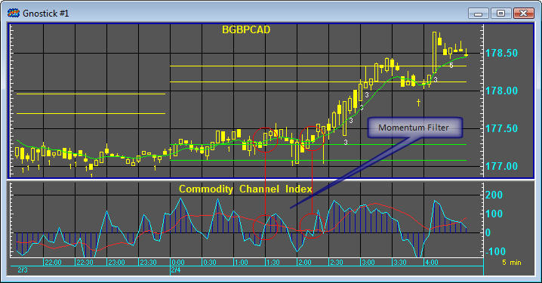
Figure 20: GnosTICK entry model with a Momentum Filter. The chart utilizes CCI Average (Commodity Channel Index) as a filter to signal a momentum-driven trade entry.

Exits – Three Varieties
When a trade is entered, exposure to market risk occurs simultaneously, making exits critical and important. Failing to exit at an appropriate level can lead to costly mistakes that have the potential to drain and ultimately deplete your trading capital.
Every trade should come with three different exit strategies. The first and most important one is the one that can limit your losses, the stop loss order. The second exit strategy is the one that can keep a profitable trade from becoming a losing trade, the trailing stop order. The last but not least exit is the profit target exit, the one that has the potential to turn you into a profitable trader in the long term. Even though all three are important, you will need to pay special attention to the stop loss and the profit target exits.
Once you have identified a trading opportunity, you will need to calculate the trades N followed by the risk reward ratio. If the trade’s risk reward ratio is not acceptable, then you can attempt to manipulate the stop loss level to tilt the risk reward ratio to an acceptable level. If doing so does not improve the ratio, then you simply pass on the trade and wait for the next trade opportunity. Generally speaking, good exits are critical and more difficult to achieve than good entries. However, the GnosTICK Levels Indicator was designed with that in mind. Therefore, once you learn and gain experience with the GnosTICK methodology, you will systematically apply the exit logic with every trade, increasing your odds further for a profitable outcome.

Stop Loss
At the core of all good exits are sound money management techniques. The stop loss order closes out trades at a specified amount, for the purpose of limiting losses to an acceptable level. Stop loss orders stay in place for the duration of the trade. As prices move in your favor, you should adjust the stop loss order level to further reduce your potential risk. You may keep adjusting as prices continue to move in your favor, ultimately to lock-in potential profits, should the markets reverse direction. There are a few ways to determine the initial stop loss level. The basic and simplest way occurs by assessing the maximum amount of money that you can lose on any given trade. The logic is money based, on pure math, an exact dollar amount at risk. Another method to set a stop loss order is on the basis of a price barrier, such as the GnosTICK Level’s bull and bear trigger levels. The logic behind this approach is directional based. Once prices penetrate through the opposite trigger level, you’re now on the opposite side of the trend, or out of the preferred direction. The ultimate goal of the stop loss order is to allow you to cut your losses short. However, setting the stop loss level involves compromise. If you set your stop loss level too close to your entry, your chances of getting stopped and out of the market increases. Should the market eventually move in your favor, you’ve sacrifice most of what would have been a profitable trade. Below is an example of a stop loss exit based on both direction and money. After a bullish entry, prices reversed causing a break of the GnosTICK bearish signal line resulting in a 40 pip loss.
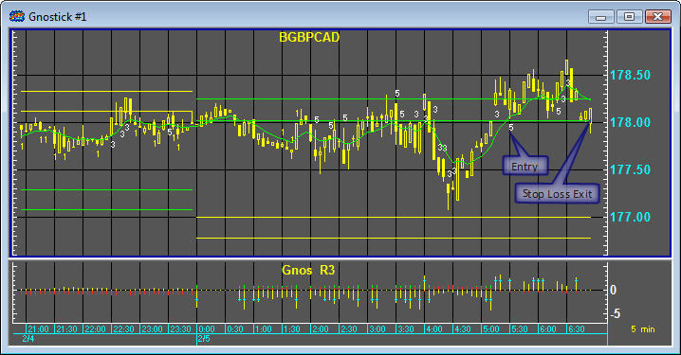
Figure 21: The chart above is of the GBP/USD demonstrating a GnosTICK stop loss model based on direction and money factors.

Trailing Stop
The goal of the trailing stop is simple and wise; never let a profit turn into a loss. Once prices move in your favor and your trailing stop order is in place, you have significantly improved your odds of a winning trade. As an overall exit strategy, it is one of the most powerful tools you can employ.
As with the stop loss order, there are a few methods to determine the trailing stop level. One basic method is by assessing the trade’s N. Once you have determined your trade’s N, you will then set your trailing stop trigger at the first third or 30% of the initial move. The logic is volatility and price based, once the market reaches an exact price, 30% of the potential move, the trailing stop order kicks in place. Another method to setting a trailing stop order is on the basis of a price barrier, such as the GnosTICK Level’s S1a or R1a. As previously mentioned in prior sections, the S1a level is firs support for shorts and R1a is the first resistance level for longs. This method is strictly volatility based, solely on the GnosTICK Level’s first targets, respectively. Trailing stops are meant to afford you the patience necessary to employ the logical money management goal of letting your profits run.
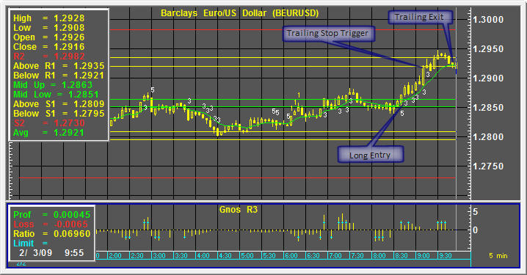
Figure 22: The chart above of the USD/JPY demonstrates the GnosTICK trailing stop model utilizing the R1a, which is 1st resistance represented by the yellow line, as the trigger to initiate the trailing stop order.

Profit Target
A profit target exit is usually employed with a limit order placed to close out a position once the market has moved to a specified price in favor of the trade. A profit target exit can be either a fixed level or be adjusted as the trade progresses. There are multiple methods to determine optimal profit target levels. The simplest and most common is volatility based utilizing the GnosTICK Levels. For long buy trades they are when prices reach first resistance, R1a defined as the first yellow line and/or second resistance, R2 defined as the outer red line. For short sell trades they are when prices reach first support, S1a defined as the first yellow line and/or second support S2 the outer red line. Another method of exiting profitable trades is math based. Profit target is constantly adjusted to the markets price movements incorporating the trailing stop orders consistent towards improving risk reward ratios. Other possible profit targets can be based on T time, which occurs when the market is approaching the markets close and prices have failed to reach your desired prices. By closing your position at the close of trading, you will be limiting your exposure should prices gap away from you at the next trading day’s open. Another method of determining a profit target exit is with technical indicators, serving as an alert that momentum has evaporated and your chances of further price movements have diminished. Trend indicators can also be used, signaling the end of a trend or a trend reversal. The illustration below uses the GnosTICK Levels R2 Profit Target exit.
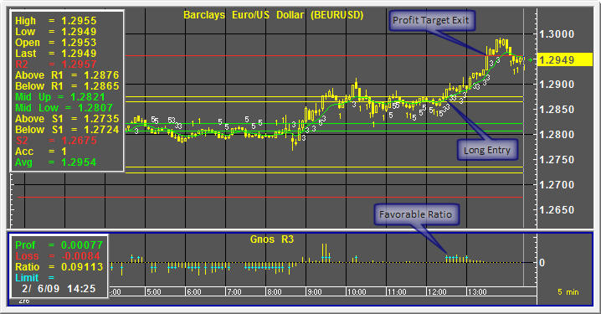
Figure 23: This chart of the Barclay’s Euro US Dollar cross demonstrates a GnosTICK profit target model utilizing the R2 line, which is 2nd resistance represented by the red line.

Market Selection – Finding the Right Edge
As you have read in previous sections, the ideal market environment to trade the GnosTICK strategies is during high volatile and/or trending markets. It is a day trading model designed to capture short term trading opportunities. Your ability to identify the most optimal trading conditions will increase your odds for success exponentially. Matching the most appropriate strategy with the market’s specific behavior will also increase your profit potential. At the start, you should trade the markets you are most familiar with. It can be very challenging and stressful to follow and scan multiple markets when they are constantly changing. As your knowledge and experience of the GnosTICK methods grow, you should then begin to familiarize yourself with other markets. Once you are able to track and identify the best markets for the GnosTICK strategy, you will then have an edge before you even place your first trade.

The Quant Report – Numeric Scanning Power
Built as a compliment to the GnosTICK levels, The Quant Report is designed to help keep you abreast of multiple markets. By tracking a diversified basket of markets, it is a great tool to assist you in selecting the appropriate markets to trade. The Quant Report employs a quantitative approach for selecting the markets that are ideal for the GnosTICK strategies. It is based on a numeric ranking system and provides pertinent information such as major and minor trend direction, temporary overbought and oversold conditions, and recurring patterns just to name a few.

Making it Happen – Learn, Train, Trade
Success in trading is a dynamic process involving a constant progression of learning, training and trading. Just like a professional athlete, training is an ongoing task. The purpose of this user guide is to give you the essential knowledge needed to get you started. You will need to devote time, energy and patience to training your new learned skills. You have heard the saying “there is nothing like the real thing”, and its true to trading. Once you begin trading live in the markets, you will experience a high degree of emotional extremes. Trading can give you a new meaning to the emotions of fear and greed. They can quickly lead you to lose focus and abandon your strategic rules needed in the trade. They can convince you to do the wrong thing not only when you have a winning position in place, but also when you have a losing position. To be a successful GnosTICK trader you will need to learn, train and trade. Yes, successful traders are always learning, training and trading.

4 GnosTICK Functions
To provide capabilities like setting alarms on GnosTICK studies, quoting GnosTICK study values, and writing formulas that use GnosTICK studies, Aspen Graphics gives you GnosTICK functions. Some GnosTICK studies display multiple lines. In such cases, Aspen Graphics provides a function for each line.
While functions can seem daunting, they are easy to use, and based strictly on the capabilities they provide, well-worth your time to discover. For example, you can make alarm that tells you when the GnosTICK Accelerator is bullish five and the GnosTICK R3 is greater than two percent. When this condition exists, you will receive an audible alert, and a notification window will pop-up on your computer. If you’re out, you can have Aspen Graphics email you. Never miss another important signal again. Just open your laptop or cell phone and the information you need is at your fingertips.
Functions consist of a name, an optional argument list in parentheses, an equal sign, and an expression. The expression can be a single line, or you can use begin/end statements or curly braces (as in Visual Basic and C, respectively) to write multi-line functions. With Aspen Graphics’ GnosTICK functions, you can write functions that test for the GnosTICK conditions you find most important to your trading.

GNOSACC()

Purpose | Returns the numeric value of the GnosTICK Accelerator study.
Syntax | GNOSACC(instrument, BearBullRange, R1Range, S1Range, Periods, AvgPeriods, ExpAveragePeriod, GnosDemarcation)
Where | Table 7: GNOSACC() function arguments.
  Argument | Function
  Instrument | An instrument symbol.  In quote windows, use $1 in this argument to reference the instrument in the first group, $2 to reference the instrument in the second group, etc.
  BearBullRange | A real number representing a percent. Default is 10.
  R1Range | A real number representing a percent. Default is 10.
  S1Range | A real number representing a percent. Default is 10.
  Periods | A number representing the number of periods in the CCI. The default is 14 for GnosTICK.
  AvgPeriod | A positive number representing the number of periods in an average. Default is 9 for GnosTICK.
  ExpAvgPeriod | A positive number representing the number of periods in an exponential average. Default is 9 for GnosTICK.
  GnosDemarcation | An enum in code. Function parms expect integer values between 0 and 3. Where:
    Value | Meaning
    0 | Use midnight at exchange
    1 | Use midnight Eastern
    2 | Use midnight GMT
    3 | Use trading hours

GNOSRRRPROFIT()

Purpose | Returns the value of the profit potential line from GnosTICK R3 study.
Syntax | GNOSRRRPROFIT(instrument, BearBullRange, R1Range, S1Range, Period, AvgPeriod, GnosDemarcation)
Where | Table 8: GNOSRRRPROFIT() function arguments.
  Argument | Function
  Instrument | An instrument symbol.  In quote windows, use $1 in this argument to reference the instrument in the first group, $2 to reference the instrument in the second group, etc.
  BearBullRange | A real number representing a percent. Default is 10.
  R1Range | A real number representing a percent. Default is 10.
  S1Range | A real number representing a percent. Default is 10.
  Period | A number representing the number of periods in the CCI. The default is 14 for GnosTICK.
  AvgPeriod | A positive number representing the number of periods in an average. Default is 9 for GnosTICK.
  ExpAvgPeriod | A positive number representing the number of periods in an exponential average. Default is 9 for GnosTICK.
  GnosDemarcation | An enumeration in code. Function parameters expect integer values between 0 and 3 where:
    Value | Meaning
    0 | Use midnight at exchange
    1 | Use midnight Eastern
    2 | Use midnight GMT
    3 | Use trading hours

GNOSRRRLOSS()

Purpose | Returns the value of the loss potential line from GnosTICK R3 study.
Syntax | GNOSRRRLOSS(instrument, BearBullRange, R1Range, S1Range, Periods, AvgPeriod, GnosDemarcation)
Where | Table 9: GNOSRRRLOSS() function arguments.
  Argument | Function
  Instrument | An instrument symbol.  In quote windows, use $1 in this argument to reference the instrument in the first group, $2 to reference the instrument in the second group, etc.
  BearBullRange | A real number representing a percent. Default is 10.
  R1Range | A real number representing a percent. Default is 10.
  S1Range | A real number representing a percent. Default is 10.
  Periods | A number representing the number of periods in the CCI. The default is 14 for GnosTICK.
  AvgPeriod | A positive number representing the number of periods in an average. Default is 9 for GnosTICK.
  ExpAvgPeriod | A positive number representing the number of periods in an exponential average. Default is 9 for GnosTICK.
  GnosDemarcation | An enum in code. Function parms expect integer values between 0 and 3. Where:
    Value | Meaning
    0 | Use midnight at exchange
    1 | Use midnight Eastern
    2 | Use midnight GMT
    3 | Use trading hours

GNOSRRRRATIO()

Purpose | Returns the value of the ratio line in the GnosTICK R3 study.
Syntax | GNOSRRRRATIO(instrument, BearBullRange, R1Range, S1Range, Periods, AvgPeriod, GnosDemarcation)
Where | Table 10: GNOSRRRRATIO() function arguments.
  Argument | Function
  Instrument | An instrument symbol.  In quote windows, use $1 in this argument to reference the instrument in the first group, $2 to reference the instrument in the second group, etc.
  BearBullRange | A real number representing a percent. Default is 10.
  R1Range | A real number representing a percent. Default is 10.
  S1Range | A real number representing a percent. Default is 10.
  Periods | A number representing the number of periods in the CCI. The default is 14 for GnosTICK.
  AvgPeriod | A positive number representing the number of periods in an average. Default is 9 for GnosTICK.
  ExpAvgPeriod | A positive number representing the number of periods in an exponential average. Default is 9 for GnosTICK.
  GnosDemarcation | An enum in code. Function parms expect integer values between 0 and 3. Where:
    Value | Meaning
    0 | Use midnight at exchange
    1 | Use midnight Eastern
    2 | Use midnight GMT
    3 | Use trading hours

GNOSLVL()

Purpose | Returns the value of the R2 line from GnosTICK Levels study.
Syntax | GNOSLVL(instrument, BearBullRange, R1Range, S1Range, GnosLevel)
Where | Table 11: GNOSLVL() function arguments.
  Argument | Function
  Instrument | An instrument symbol.  In quote windows, use $1 in this argument to reference the instrument in the first group, $2 to reference the instrument in the second group, etc.
  BearBullRange | A real number representing a percent. Default is 10.
  R1Range | A real number representing a percent. Default is 10.
  S1Range | A real number representing a percent. Default is 10.
  GnosLevel | An enum in code. Function parms expect integer values between 0 and 3 where:
    Value | Meaning
    0 | Use midnight at exchange
    1 | Use midnight Eastern
    2 | Use midnight GMT
    3 | Use trading hours

GNOSLVLAR1()

Purpose | Returns the Above R1 line from GnosTick Levels.
Syntax | GNOSLVLAR1(instrument, BearBullRange, R1Range ,S1Range, GnosLevel)
Where | Table 12: GNOSLVLAR1() function arguments.
  Argument | Function
  Instrument | An instrument symbol.  In quote windows, use $1 in this argument to reference the instrument in the first group, $2 to reference the instrument in the second group, etc.
  BearBullRange | A real number representing a percent. Default is 10.
  R1Range | A real number representing a percent. Default is 10.
  S1Range | A real number representing a percent. Default is 10.
  GnosLevel | An enum in code. Function parms expect integer values between 0 and 3 where:
    Value | Meaning
    0 | Use midnight at exchange
    1 | Use midnight Eastern
    2 | Use midnight GMT
    3 | Use trading hours

GNOSLVLBR1()

Purpose | Returns the Below R1 line from GnosTICK Levels.
Syntax | GNOSLVLBR1(instrument, BearBullRange, R1Range, S1Range, GnosLevel)
Where | Table 13: GNOSLVLBR1() function arguments.
  Argument | Function
  Instrument | An instrument symbol.  In quote windows, use $1 in this argument to reference the instrument in the first group, $2 to reference the instrument in the second group, etc.
  BearBullRange | A real number representing a percent. Default is 10.
  R1Range | A real number representing a percent. Default is 10.
  S1Range | A real number representing a percent. Default is 10.
  GnosLevel | An enum in code. Function parms expect integer values between 0 and 3 where:
    Value | Meaning
    0 | Use midnight at exchange
    1 | Use midnight Eastern
    2 | Use midnight GMT
    3 | Use trading hours

GNOSLVLMU()

Purpose | Returns the Mid Up line from GnosTICK Levels.
Syntax | GNOSLVLMU(instrument, BearBullRange, R1Range, S1Range, GnosLevel)
Where | Table 14: GNOSLVLMU() function arguments.
  Argument | Function
  Instrument | An instrument symbol.  In quote windows, use $1 in this argument to reference the instrument in the first group, $2 to reference the instrument in the second group, etc.
  BearBullRange | A real number representing a percent. Default is 10.
  R1Range | A real number representing a percent. Default is 10.
  S1Range | A real number representing a percent. Default is 10.
  GnosLevel | An enum in code. Function parms expect integer values between 0 and 3 where:
    Value | Meaning
    0 | Use midnight at exchange
    1 | Use midnight Eastern
    2 | Use midnight GMT
    3 | Use trading hours

GNOSLVLML()

Purpose | Returns the Mid Low line from GnosTICK Levels.
Syntax | GNOSLVLML(instrument, BearBullRange, R1Range, S1Range, GnosLevel)
Where | Table 15: GNOSLVLML() function arguments.
  Argument | Function
  Instrument | An instrument symbol.  In quote windows, use $1 in this argument to reference the instrument in the first group, $2 to reference the instrument in the second group, etc.
  BearBullRange | A real number representing a percent. Default is 10.
  R1Range | A real number representing a percent. Default is 10.
  S1Range | A real number representing a percent. Default is 10.
  GnosLevel | An enumeration in code. Function parameters expect integer values between 0 and 3 where:
    Value | Meaning
    0 | Use midnight at exchange
    1 | Use midnight Eastern
    2 | Use midnight GMT
    3 | Use trading hours

GNOSLVLAS1()

Purpose | Returns the Above S1 line from GnosTICK Levels.
Syntax | GNOSLVLAS1(instrument, BearBullRange, R1Range, S1Range, GnosLevel)
Where | Table 16: GNOSLVLAS1() function arguments.
  Argument | Function
  Instrument | An instrument symbol.  In quote windows, use $1 in this argument to reference the instrument in the first group, $2 to reference the instrument in the second group, etc.
  BearBullRange | A real number representing a percent. Default is 10.
  R1Range | A real number representing a percent. Default is 10.
  S1Range | A real number representing a percent. Default is 10.
  GnosLevel | An enumeration in code. Function parameters expect integer values between 0 and 3 where:
    Value | Meaning
    0 | Use midnight at exchange
    1 | Use midnight Eastern
    2 | Use midnight GMT
    3 | Use trading hours

GNOSLVLBS1()

Purpose | Returns the Below S1 line from GnosTICK Levels.
Syntax | GNOSLVLBS1(instrument, BearBullRange, R1Range, S1Range, GnosLevel)
Where | Table 17: GNOSLVLBS1() function arguments.
  Argument | Function
  Instrument | An instrument symbol.  In quote windows, use $1 in this argument to reference the instrument in the first group, $2 to reference the instrument in the second group, etc.
  BearBullRange | A real number representing a percent. Default is 10.
  R1Range | A real number representing a percent. Default is 10.
  S1Range | A real number representing a percent. Default is 10.
  GnosLevel | An enumeration in code. Function parameters expect integer values between 0 and 3 where:
    Value | Meaning
    0 | Use midnight at exchange
    1 | Use midnight Eastern
    2 | Use midnight GMT
    3 | Use trading hours

GNOSLVLS2()

Purpose | Returns the S2 line from GnosTICK Levels.
Syntax | GNOSLVLS2(instrument, BearBullRange, R1Range, S1Range, GnosLevel)
Where | Table 18: GNOSLVLS2() function arguments.
  Argument | Function
  Instrument | An instrument symbol.  In quote windows, use $1 in this argument to reference the instrument in the first group, $2 to reference the instrument in the second group, etc.
  BearBullRange | A real number representing a percent. Default is 10.
  R1Range | A real number representing a percent. Default is 10.
  S1Range | A real number representing a percent. Default is 10.
  GnosLevel | An enumeration in code. Function parameters expect integer values between 0 and 3 where:
    Value | Meaning
    0 | Use midnight at exchange
    1 | Use midnight Eastern
    2 | Use midnight GMT
    3 | Use trading hours

5 EMAIL ALERTS
Aspen Graphics makes it possible to notify yourself by email when market conditions are favorable for a long or short position, according to GnosTICK entry rules. To do this, you need to know how to write a formula, and how to create an alarm.

Writing a Formula
The first order of business necessary to create an email notice is to write a formula. According to GnosTICK rules, entry signals occur when the GnosTICK Ratio is greater than the Ratio Limit (by default, 2). Basically, the GnosTICK Ratio is the quotient of the difference of Target Price and the current price divided by the difference between the current price and the Stop Loss. Further, favorable entry conditions exist when the GnosTICK Accelerator yields a value of 1, 3, or 5, 5 being the strongest signal, 1 the weakest.
Using the Aspen Graphics Formula Manager, it is possible to create an expression that will indicate when both the GnosTICK Ratio and Accelerator are giving favorable entry signals. To do this, first display the Formulas dialog. On the menu bar, click Tools and then Formulas…
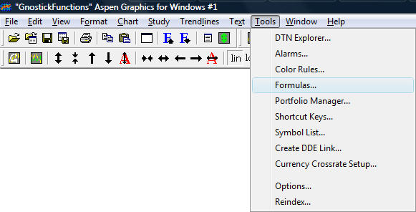
Table 19: Tools Menu, Formulas… selection.

This displays the Formulas Manager:
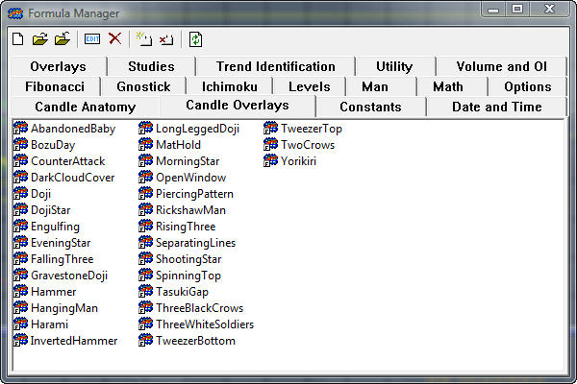
Figure 24: Formula Manager.
.In the button bar, click the new formula button:
This displays the Formula Editor, ready for you to write a formula.
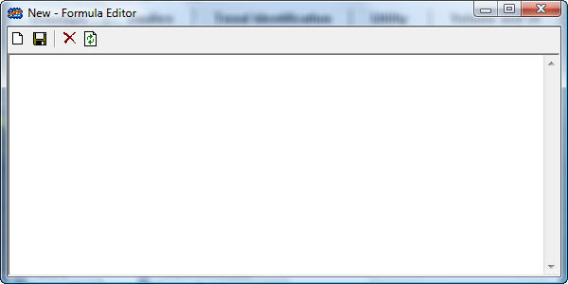
Figure 25: Formula Editor.
Now you are ready to write. Consider the following formula:
analyse(instrument, minimum_ratio)=begin
ReturnValue = 0
AcceleratorValue=v5chart(GNOSACC(instrument,10,10,10,14,9,9,3))
Ratio=v5chart(GNOSRRRRATIO(instrument,10,10,10,14,9,3))
r=abs(ratio)
if r >= min_ratio then begin
ReturnValue = AcceleratorValue
end
ReturnValue
end
Although formulas can be daunting, they are far simpler than you might imagine. There are a few conventions to observe, but they are easy to understand and make sense once you get some experience writing expressions. When it comes to learning Aspen Graphics’ formula language, having a specific objective in mind promotes comprehension. To this end, let’s examine how to write a formula that uses confirming signals from both the GnosTICK Ratio and the GnosTick Accelerator to qualify long and short entry opportunities.

What’s In A Name?
Aspen Graphics formula names adhere to the following syntax:
The first element in a formula name is the name itself. See name in the example above. A name can be anything, but there is a family of words you should avoid. First, you should avoid duplicating formula names. Where duplicates exist, Aspen Graphics will only compile the first one formula it finds. Second, avoid using Aspen Graphics commands and internal constants. For example, you wouldn’t want to name a formula RSI because it conflicts with the .RSI command. Consider using a name like my_rsi instead. Third, names should not contain spaces. Use underscores, or just mush the words together using initial capital letters to make them easy to read. Don’t worry if you break any of these rules. None will result in problems that cannot be easily fixed.
In our formula, the first line is analyse(instrument, minimum_ratio)=begin. Analyse is the name:
analyse(instrument, minimum_ratio)=begin
The second element is a pair of parentheses containing formula arguments. An argument is a value the formula uses to produce its value. The most common argument you will encounter is a reference to an instrument. In our example, there are two arguments, instrument, and minimum_ratio:
analyse(instrument, minimum_ratio)=begin
When you use, or call, this function, you must include the parentheses and supply values for the two arguments.
While you can use almost any word as an argument, it is very helpful to use words that describe what the argument is.
The third element in the formula name is an equal sign (=). The equal sign terminates the name and argument.
Following the equal sign, you will encounter one of two things:
- An expression
- A multi-line function directive
If you have a simple expression like a spread (instrument1-instrument2, for example), simply write it after the equal sign. By contrast, if your expression is more complex, use a multi-line function directive. Aspen Graphics recognizes two mutli-line function directives:
- begin… end (Visual Basic)
- {…} (C, C++, C#)
In our example, we have some data collection to do and some logic to apply, so the multi-line function directive follows the equal sign:
analyse(instrument, minimum_ratio)=begin
We could use the opening curly brace instead of begin. Both will work. However, you can’t open with begin and end with a }, nor vice versa.
When you open a formula with a multi-line formula directive, you may find it helpful to hit the Enter key a few times and type it’s companion terminator (end, or } ). This practice is a good way to avoid unnecessary head-scratching over compiler errors.

Declaring Variables
The first four lines of our expression are variable declarations that have value assignments:
ReturnValue = 0
AcceleratorValue=v5chart(GNOSACC(instrument,10,10,10,14,9,9,3))
Ratio=v5chart(GNOSRRRRATIO(instrument,10,10,10,14,9,3))
r=abs(ratio)
First, ReturnValue declares the variable named ReturnValue. The equal sign and the 0 assign the variable ReturnValue a value of 0. Declaring a variable and assigning it a value in the same statement is called initializing a variable. Similarly, AcceleratorValue and Ratio are variables that are initialized with values returned by the GNOSACC() and GNOSRRRRATIO() functions, respectively .
Note that the GNOSASS() and GNOSSRRRRATIO() functions are wrapped by a v5chart() function. The v5chart() function creates a five-minute chart in memory, thus permitting the current value returned by this formula to be displayed in a quote window.
Finally, the variable r is assigned the absolute value of number returned by the GNOSRRRRATIO() function. The GNOSRRRRATIO() function can return positive or negative values, depending on the direction of a market. We really don’t care about the sign of the value, but we do care whether the current ratio is greater than the Ratio Limit, a concept that describes the current price’s distance from the Stop Loss. By converting a negative value to a positive value, we can then test it against a positive Ratio Limit and avoid testing for both positive and negative conditions.

Using Aspen Functions
GnosTICK Levels and R³ produce more than one line. Aspen Graphics has a function for every value produced by GnosTICK Studies. The following table relates each study value to its respective function:
Study | Value | Function
Levels | R2 | GNOSLVL()
 | Above R1 | GNOSLVLAR1()
 | Below R1 | GNOSLVLBR1()
 | Mid Up | GNOSLVLMU()
 | Mid Low | GNOSLVLML()
 | Above S1 | GNOSLVLAS1()
 | Below S1 | GNOSLVLBS1()
 | S2 | GNOSLVLS2()
Accelerator | Accelerator | GNOSACC()
R³ | Profit | GNOSSRRRPROFIT()
 | Loss | GNOSRRRLOSS()
 | Ratio | GNOSRRRRATIO()
 | Limit | N/A
Table 20: GnosTICK values and their functions.
Note there is no function for R3’s Limit value. There are two reasons for this: first, the Ratio Limit is a reflection of a study parameter, not a calculated value; second, Ratio Limit is better handled on a function-by-function basis—the same function can be used in a variety of markets if the Ratio Limit is not static.
When calling an Aspen Graphics function, it always helps to consult the documentation to check for the number of arguments expected, and what values are permissible. Let’s take a closer look at using an Aspen Graphics function. Since the GNOSASS() function has the longest argument list, let’s use it as an example. The syntax for the function is:
GNOSACC(instrument, BearBullRange, R1Range, S1Range, Periods, AvgPeriods, ExpAveragePeriod, GnosDemarcation)
The first thing to do when calling an Aspen Graphics function is to count the number of arguments between the parentheses. In this instance, there are eight arguments. This means the function we write must contain eight arguments. If you call the formula with more or fewer arguments, it will produce no value.
Rarely, an Aspen Graphics function has an optional argument. In such cases, the required arguments must be included, whether the optional argument is used or not.
As you review the arguments, pay attention to the word used for each. As a rule, it’s a good idea to be as descriptive as possible about variables and arguments when naming them. This practice helps you figure out what’s expected. This is of tremendous benefit when you haven’t seen a formula in a long time. Let’s examine the arguments of the GNOSACC() function:

Argument | Function
Instrument | As the name indicates, this argument is a reference to an instrument. You could enter a symbol as this argument. More commonly, however, you will use $1, an Aspen Graphics convention that has several meanings, depending on context:
  Context | Function
  Quote Windows | Passes the first symbol in the quote window to this argument. Were you to use $2, you’d get the second symbol in the quote window, $3 the third, and so on.
  Charts | Passes the first symbol in the chart to this argument. Where more than one symbol exists, the use of $2 and $3 is like a quote window.
BearBullRange | The Accelerator depends on the GnosTICK Levels study. Recall the lines that make up the GnosTICK Accelerator study. The center lines, Mid Up and Mid Low, define a range, expressed as a percentage. This parameter is that percentage. Larger numbers increase the range while smaller numbers constrict it.
R1Range | Again, this parameter controls the range between the R1 (Resistance 1) lines.
S1Range | Based on the roles of the last two parameters, can you surmise the role of this one?
Periods | This is an example of a well-named argument. One element in the Accelerator calculation is a Commodity Channel Index (CCI) study value. The CCI requires a number of periods. This argument lets you specify the CCI’s number of periods.
AvgPeriod | This is an example of a less-well named argument. While it’s clear that this argument defines a number of periods for an average, there’s nothing to indicate what kind of average. As it turns out, the Accelerator study also relies on the AverageCCI study, which requires a number of periods. How much more descriptive would this argument be with the name CCIAvgPeriod?
ExpAvgPeriod | GnosTICK Levels also rely on an exponential moving average. This argument defines the number of periods for this moving average.
GnosLevel | The Accelerator requires Gnos Levels. This is an example of an argument that, until you memorize permitted values, requires keeping the documentation close by. This argument can be any of four values. Each causes Aspen Graphics to use a different code path. This argument controls how GnosTICK Levels are defined. The following table summarizes these options:
  Value | Meaning
  0 | Use midnight at exchange
  1 | Use midnight Eastern
  2 | Use midnight GMT
  3 | Use trading hours
Table 21: A closer look at GnosTICK Accelerator arguments and their functions.
Fortunately, most Aspen Graphics functions have far fewer arguments than GNOSACC(). Now that you’ve had a closer look at its arguments and what values they expect, let’s turn our attention to calling this function. As mentioned earlier, a successful call depends on argument order and number. Mixing argument order may not make the function fail, but it can produce incorrect values, which is often more problematic than producing no value at all. Using too many or too few arguments and the function won’t calculate. A successful call looks like this:
AcceleratorValue=v5chart(GNOSACC(instrument,10,10,10,14,9,9,3))
The number and order of arguments is correct, and this call will return the value produced by the GnosTICK Accelerator. By assigning it to the AcceleratorValue variable, you can reference the Accelerator value throughout the formula without calling GNOSACC() again.

Logic And Flow
Most trading systems require multiple analyses. It’s one thing for a study to give you a favorable signal; it’s quite another for two or more studies to indicate favorable conditions simultaneously. In GnosTICK analysis, three studies work in unison to signal profitable entry and exit conditions.
Our example formula uses an if statement to test the value of the GnosTICK Ratio. Again, the Ratio is the quotient of the potential reward divided by the potential risk. One attribute of a favorable entry point in the GnosTICK scheme is a Ratio greater than 2. If we call the function like this,
Analyse($1,2)
the min_ratio argument will be two. By comparing min_ratio to the absolute value of GnosTICK Ratio, we can weed out Accelerator signals that are too risky. When the Ratio’s absolute value is greater than min_ratio, the formula assigns the AcceleratorValue to the ReturnValue variable.
if r >= min_ratio then begin
ReturnValue = AcceleratorValue
end
It is possible for AcceleratorValue to be nothing, but that’s a condition we can handle at the Alarm level. Since the Accelerator provides degrees of signal strength, we’ll tap that feature to provide content for our email messages. For now, we’re only concerned that the Ratio gives a favorable signal.
Since an Aspen Graphics formula returns the last value referenced, the last line in the expression is simply,
ReturnValue
By initializing the variable ReturnValue to 0, this formula will produce the following values:
Value | Meaning
-5 | Strong sell signal
-3 | Medium sell signal
-1 | Weak sell signal
0 | Unfavorable Ratio
1 | Weak buy signal
2 | Medium buy signal
3 | Strong buy signal
No Value | Favorable Ratio—no Accelerator signal
Table 22: The range of possible return values from the analyse() formula.
The GnosTICK Accelerator returns positive values for both long and short signals. Long signals appear beneath a bar while short signals appear above. Since there’s no visual cue to indicate long or short, GNOSACC() uses positive numbers to identify long signals and negative numbers to indicate short signals.

Creating an Alarm
Now that we have a formula that tells us when GnosTICK market entries exist, we can use this formula to create alarms. Aspen Graphics’ alarms are terrific for detecting market conditions for you, freeing you up to examine other factors that can affirm or negate trading decisions.
To write an alarm, open the Tools menu and select Alarms…
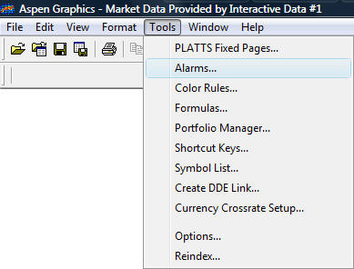
Figure 26: The Alarms… selection.
Selecting Alarms… displays the Alarms List.
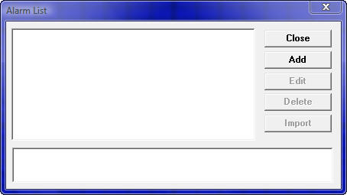
Figure 27: The Alarm List.
In the figure above, the Alarm List is empty. To create an alarm, click the Add button. This displays the New Alarm dialog.
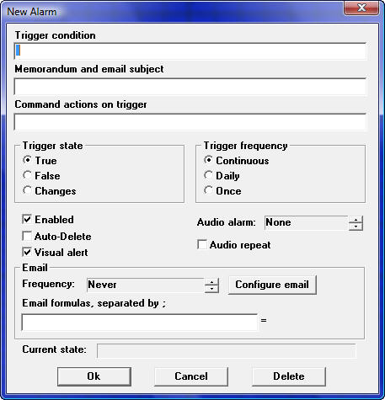
Figure 28: The New Alarm dialog.
The central element of any alarm is its trigger condition. The next order of business is to write a trigger condition that alerts us when GnosTICK long and short market entries exist. To do this, we simply enter an analyse() function call in the trigger condition field and test it for one of its possible return values.
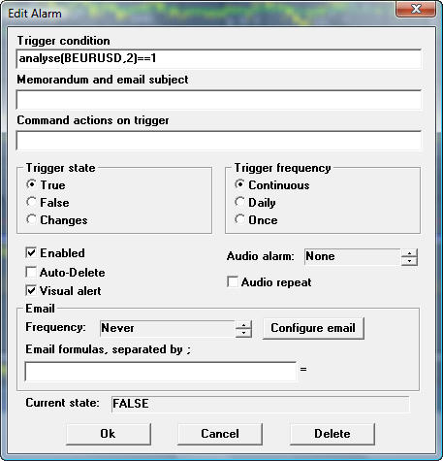
Figure 29: Using the analyse() formula as a Trigger condition.
In this example, we are testing for a weak GnosTICK long entry.
Note the use of the double equal sign (==). The double equal sign operator means compare, whereas the single equal sign means assign, or equate. If you try to use a single equal sign, the trigger condition will generate a syntax error.
Since this alarm will only trigger when analyse() returns a value of 1, we know that this is a weak buy signal (see, table 28). Hence, what we enter into the memorandum field should be very specific about the condition detected by the alarm because the content of the memorandum serves as both the subject line of an email and the alarm description in Aspen Graphics, a subject we will get to later.
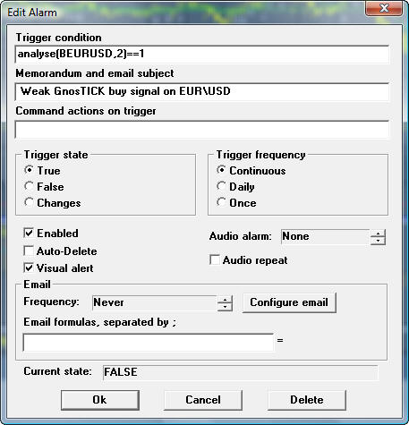
Figure 30: Entering descriptive information about the alarm in the Memorandum field.
To make an alarm email you, business partners, or even clients, you must first provide Aspen Graphics with your email configurations. To do this, click the Configure email button. This displays the Setup Options dialog, open to the Email tab.
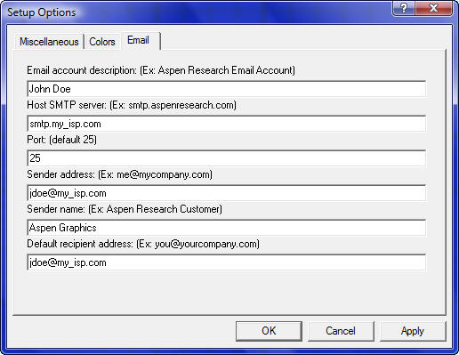
Figure 31: Using the analyse() formula as a Trigger condition.
Here, you provide the details of your email account. Aspen Graphics uses this information to email messages about triggered alarms. When you have provided the required information, click OK to return to the Alarms dialog.
Note that the email address in the “Default recipient address” is the primary target for email alerts, presumably yourself. You can enter additional recipients in the Alarm dialog’s “Email formulas” field.
Next, you need to specify the frequency email alerts should be sent. To do this, select an option from the Frequency list box. The options are as follows:
Option | Function
Never | Suppresses email notification. In essence, setting an alarm to Never turns email notification off.
Once | When a trigger condition is met, this setting causes a single email notice to be sent out.
Always | Every time a trigger condition is met, this setting sends an email. This can result in a lot of email notices when market conditions are right.
Finally, if you would email notices to go out to colleagues, business partners, or clients, enter their emails addresses separated by semi-colons (;) in the email formulas field.
To save the alert, click OK. This returns you to the Alarms List dialog. The trigger condition of the alarm appears in the list view.
For every market condition you want to alert, you need to write an alarm.
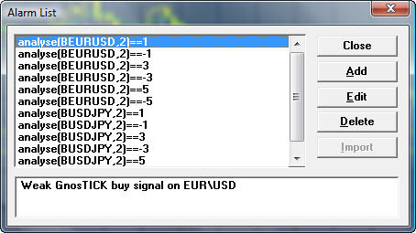
Figure 32: Setting alerts on several instruments.
When you receive an email alert, notice that the content of the Alarm Dialog’s Memorandum field serves as the subject line, and the trigger condition serves as the message body.
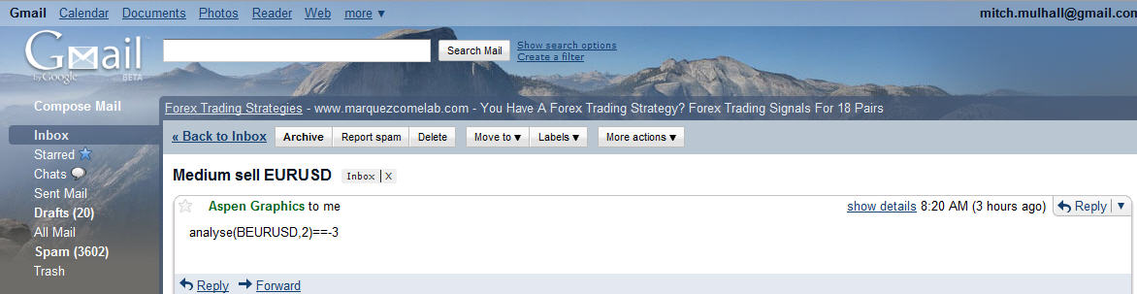
Figure 33: An email alert.
Email alerts helpful when you are away from your computer. Use your cell phone or PDA to access your email and you’ll be on top of the market 24-7. When you are at your computer, Aspen Graphics displays a pop-up that details all alerts that have triggered.
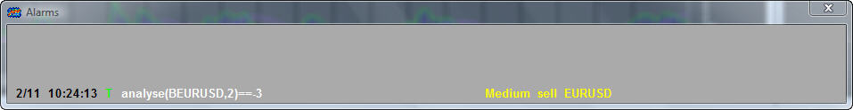
Figure 34: The Aspen Graphics alarm window.

Index

References

